School of Computing, Creative Technologies, and Engineering 2021/22
Level 6 Production Project
MEETING RECORD SHEET: |  |  | Meeting  Number: 3
Student: Anupam Siwakoti |  | Student I.D.: C7227267
Date of Meeting: March 5th, 2022 |  | Supervisor: Resham Bdr Pun
Actions agreed at previous meeting (completed or comment):
1 | Using spring framework for layered architecture ¨
2 | DDD concepts are implemented (which will be same for all architectures) ¨
3 | Continuing with writing the literature review ¨
4 | ¨
5 | ¨
6 | ¨
Comments of student (if any):
This was the third meeting with our supervisor, he saw the progress.

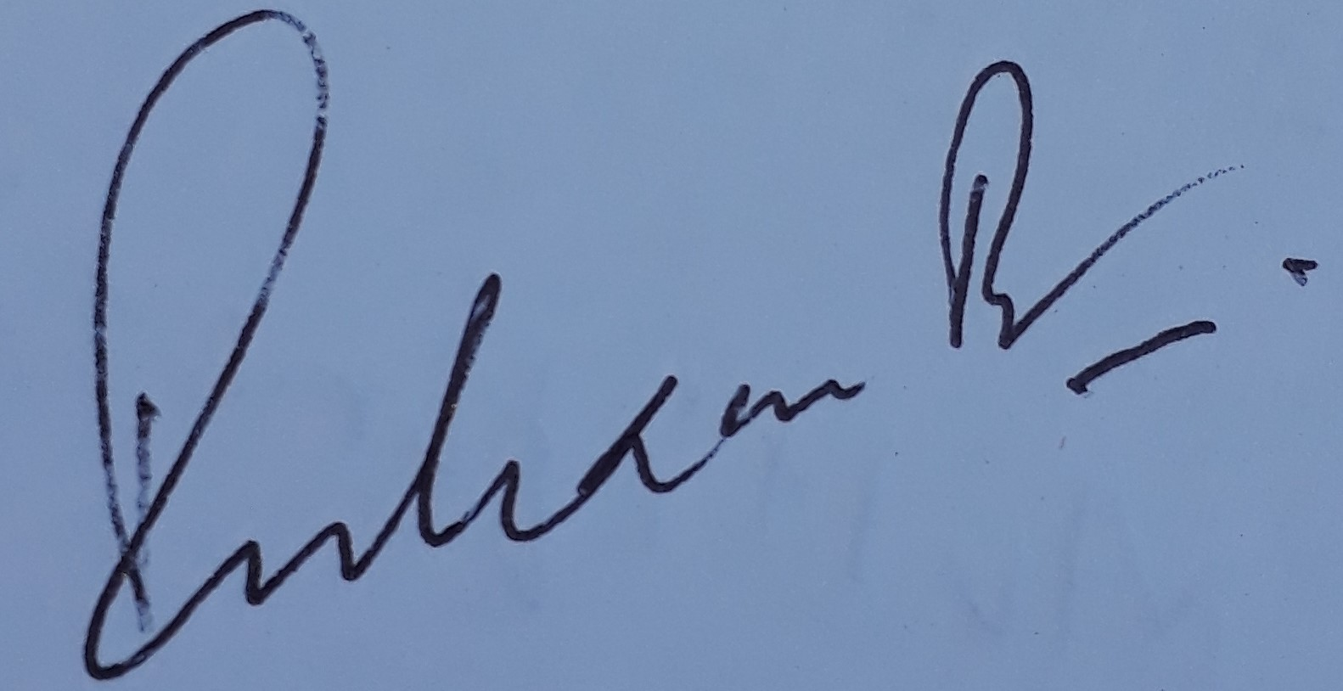
ABOVE here – student to complete before Meeting with supervisor. BELOW here – complete at the Meeting.
Next meeting (date/time): March 12th, 2022
Agreed Actions to complete before next meeting:
1 | Local server setup, database management (in memory)
2 | Write down all the step-up procedure for the project setup
3
4
5
6
Comments of supervisor (if any):
He is continuing with implementing prototype along with his learnings.

